Problem 1 [10 pts]:
(a) Identify all instant centers for this mechanism. Compute how many instant centers should there be in the mechanism. Identify all instant centers (ICs) for the mechanism using a linear graph to track them. Use the labeling convention from class to label each instant center, e.g., I₁₃. Show construction lines if needed (Rules 2,3,5).
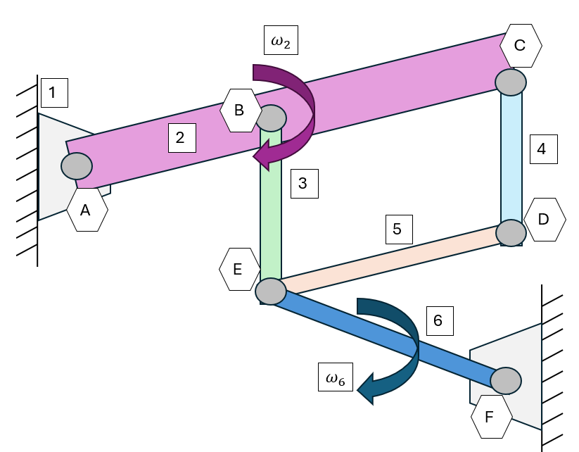
(b) If link 2 is rotating with a constant velocity $ω_{2}$, write down an expression for the instantaneous angular velocity of link 6, $ω_{6}$, in terms of $ω_{2}$ and distances between points available in the linkage diagram with the instant centers in it (e.g., |I₁₂I₃₄| is the length of or O₄I₃₅, etc.)

Problem 2 [10 pts]: At the instant shown, the piston has a velocity, ${\vec{V}}_{A}=V_{A}\hat{i}$
Using instant centers, determine the angular velocity $ω_{BC}$ of the crankshaft. Identify all instant centers for this mechanism. Show all work similar to Problem 1. Use the following parameters:
$$L=0.20m$$ | $$R=0.05m$$ | $$φ=45°$$ | $$V_{A}=-8m/s$$
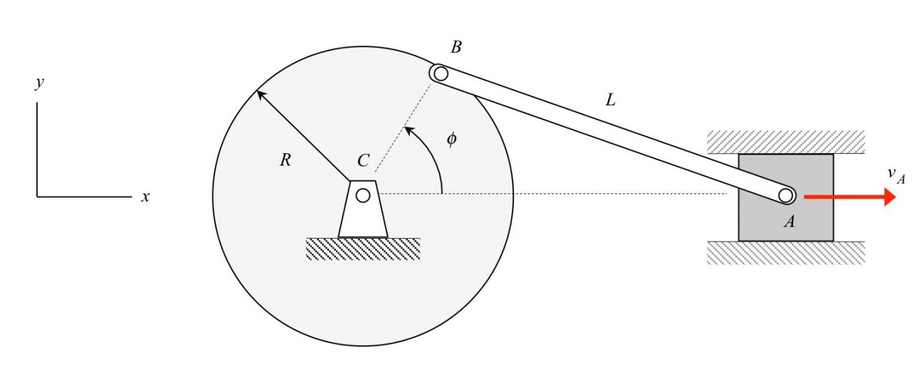

Select one of the following options:
- My answer was created by a Gen AI algorithm, and I have not modified it
- My answer was created by a Gen AI algorithm, and I have made some minor changes.
- My answer was created by a Gen AI algorithm, and I have made major changes.
- My answer was created solely by myself.
- If I used Gen AI, I used ___ (name of program).

